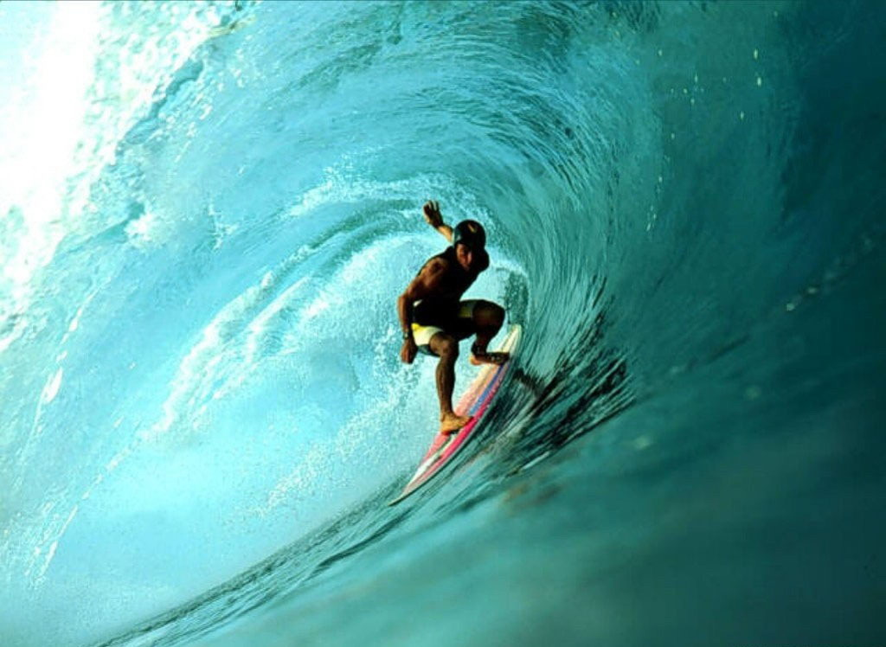
The URI Surf Club is going on a mission trip to Nicaragua! We’re also planning to throw a bad fish concert, travel to Long Island for the pro-contest, and much more! JOIN TO FIND OUT!

Meetings: Thursdays @ 5pm in Room 308 in Memorial Union!
  - President: Patrick Brown
  - Phone: 401-215-6988
  - Email: simplybrown2014@gmail.com
  - Website: http://www.facebook.com/home.php#!/group.php?gid=112290542163967

URI SURF CLUB!
(xxx) yyy-yyyy

